FOOD AND NUTRITION

You’re headed into your ninth year. Over the course of your career, have you altered your approach to dieting at all?
I’ve never really had to mess around with my diet—I never felt like any type of food really gave me a huge advantage. That said, my diet is heavy on carbs and protein, and I try and eat as many vegetables as possible. I stay away from fruit, and I’m not a big sweet-tooth guy. I don’t really like chocolate or ice cream. If I’m going to cheat, it’s going to be a cheeseburger or a slice of pizza.
As you play more and get older, your metabolism can slow down a bit, but mine is still pretty good. I find that if I don’t eat as much, I get low on energy. So for me, after I exercise, it’s about getting as many carbs and proteins in me as possible, and having carbs throughout the day to make sure my energy level stays high. If I do that, usually I feel pretty good.
You’re missing out on sweets! Do you at least enjoy more the cheat days during the offseason?
Oh, I’ll take a couple of weeks and have a few more cheeseburgers or some more pizza than I otherwise would. I try to stay pretty consistent with my diet, though. I like eating well and finding new foods that I like. I live in Toronto, so there’s a lot of food options downtown, whether you want Indian food or Mexican—I think an Australian place recently opened up near me, too. It’s fun to try out new foods and see what you discover.
What does your game-day eating schedule look like?
In the morning, it’s pretty simple: I have eggs with oatmeal and sausages. I try and mix in a green juice with breakfast as well. From there, my pre-game meal is gluten-free pasta. I’ll have some meat sauce with it, and salmon. I really love salmon because it has a lot of protein, and my body always seems to digest it really well. I like it a lot more than chicken because I feel like it has more flavor.
I’ll go home and take my nap and then have a snack when I wake up. Usually, that’s some rice and salmon again, this time with broccoli. I’ll have another green juice as well. When I get to the game, it’s all about getting electrolytes in me and making sure I’m hydrated. There’s a drink called Catalyte and another called Amino Complex—I mix those together, and I have that for about four to five hours during the lead-up to the game, and more during the game. I find that fuels me pretty well.

Source: Cason, Christopher. “The Real-Life Diet of Taylor Hall, the Most Valuable Player in Hockey.” GQ. 25 Oct 2018. https://www.gq.com/story/taylor-hall-real-life-diet

Nutrition pyramid
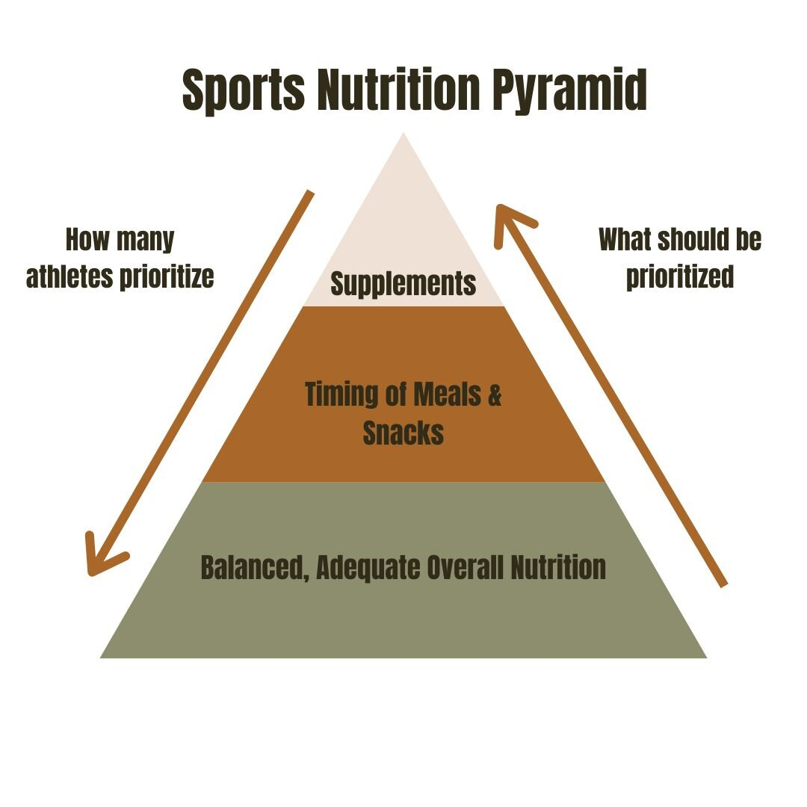
Source: “The sports nutrition pyramid.” Nutrition with Anna LLC. 2 Nov 2020. https://www.nutritionwithanna.com/blog/sports-nutrition-pyramid

Vocabulary:
protein
fiber
carbs

